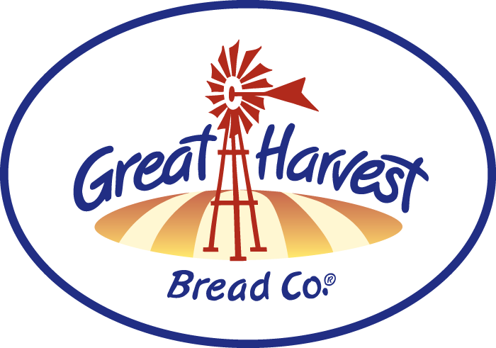
Grundy School PTO
Fundraiser Day
Great Harvest Bread Co.
664 W. Jackson, Morton
(309) 263-0300
Great Harvest Bread Co. will donate 15% of all sales accompanied with this flyer to the Grundy School PTO.
Tuesday & Wednesday, Oct 5 & 6, 2021
From 7:00AM - 5:00PM
Thank You For Your Support!

